**EMPOWERING RESTURANTS AND INCREASING REVENUE BY DATA ANALYTICS**

**Introduction:**

One of the most challenging things for restaurateurs is to comprehend what affects their popularity more – whether it is the food or the ambiance or the crowd or the service or the mood in the restaurants. They would definitely love gaining access to information on the type of customers visiting their stores, seasonal trends of items sold, performance across venues and several other parameters. This is where Data science comes very useful as lifesavers for restaurateurs

To increase the revenue of restaurants by analyzing food habits of the customer in the restaurant and by identifying huge population, new food combinations introducing and attract the customers in that regions.

Analytics to use to understand Customer Expectations and increase Revenue:

1. Understanding customer’s  
2.Analyse customer behavior  
3.Analyse menu items observing what people are consuming and what they are not

**Methodology:**

1. There are 422 restaurants in Croydon, London out of which 52 are Indian cuisines

2. The revenues of these 52 restaurants have to be increased.

3. The population of Croydon is 375k and will find the average customers visiting the Indian restaurants and will find out their order by their visits.

**Data:**

I will be using Foursquare to utilize location data and explore London to identify the London boroughs that requires to identify the restaurants in the specific regions. More number of sales increases the revenue of the restaurant.

In order to increase the revenue, food habits of the region has to be analyzed and new food items will be introduced in the menu.

Areas will be identified that:

1. Have large Populations  
2.Have more restaurants  
3.Have more children.

4. Have more number of Indian population

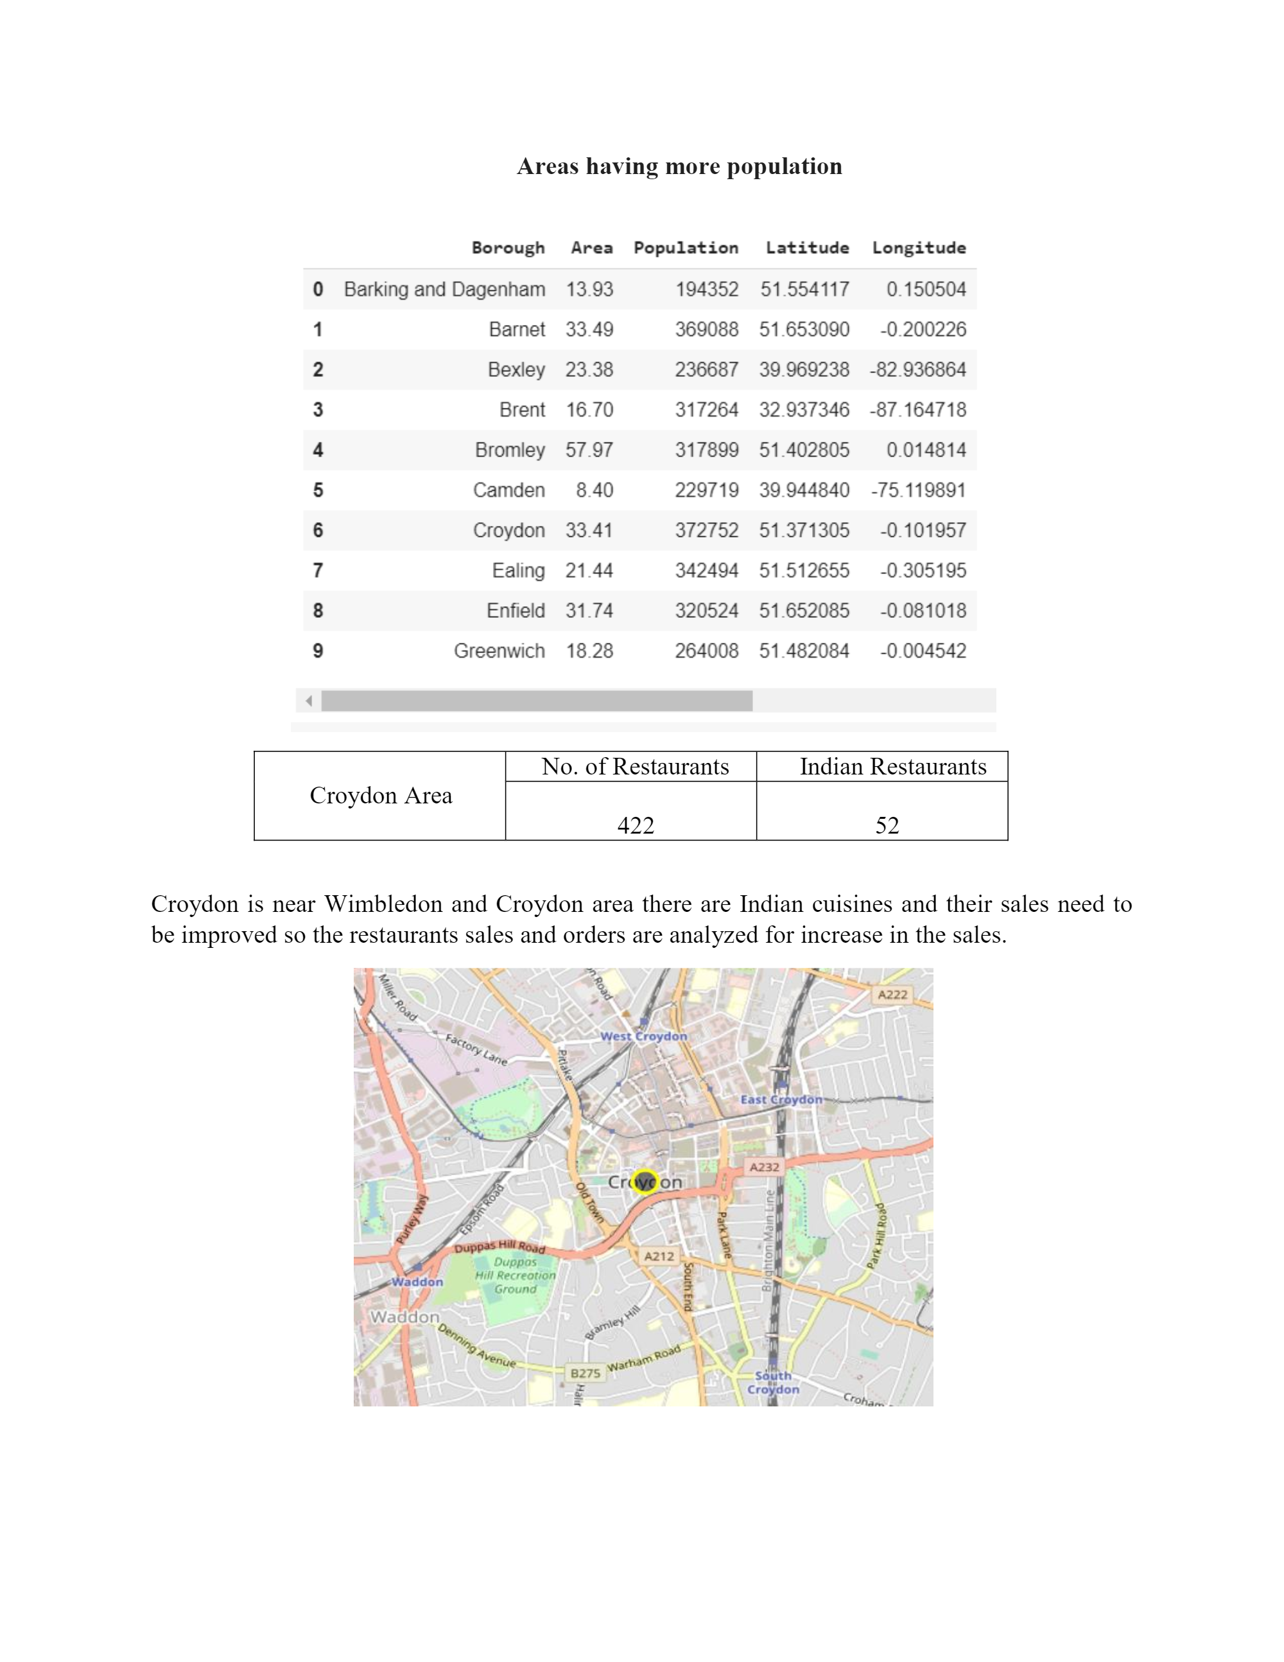

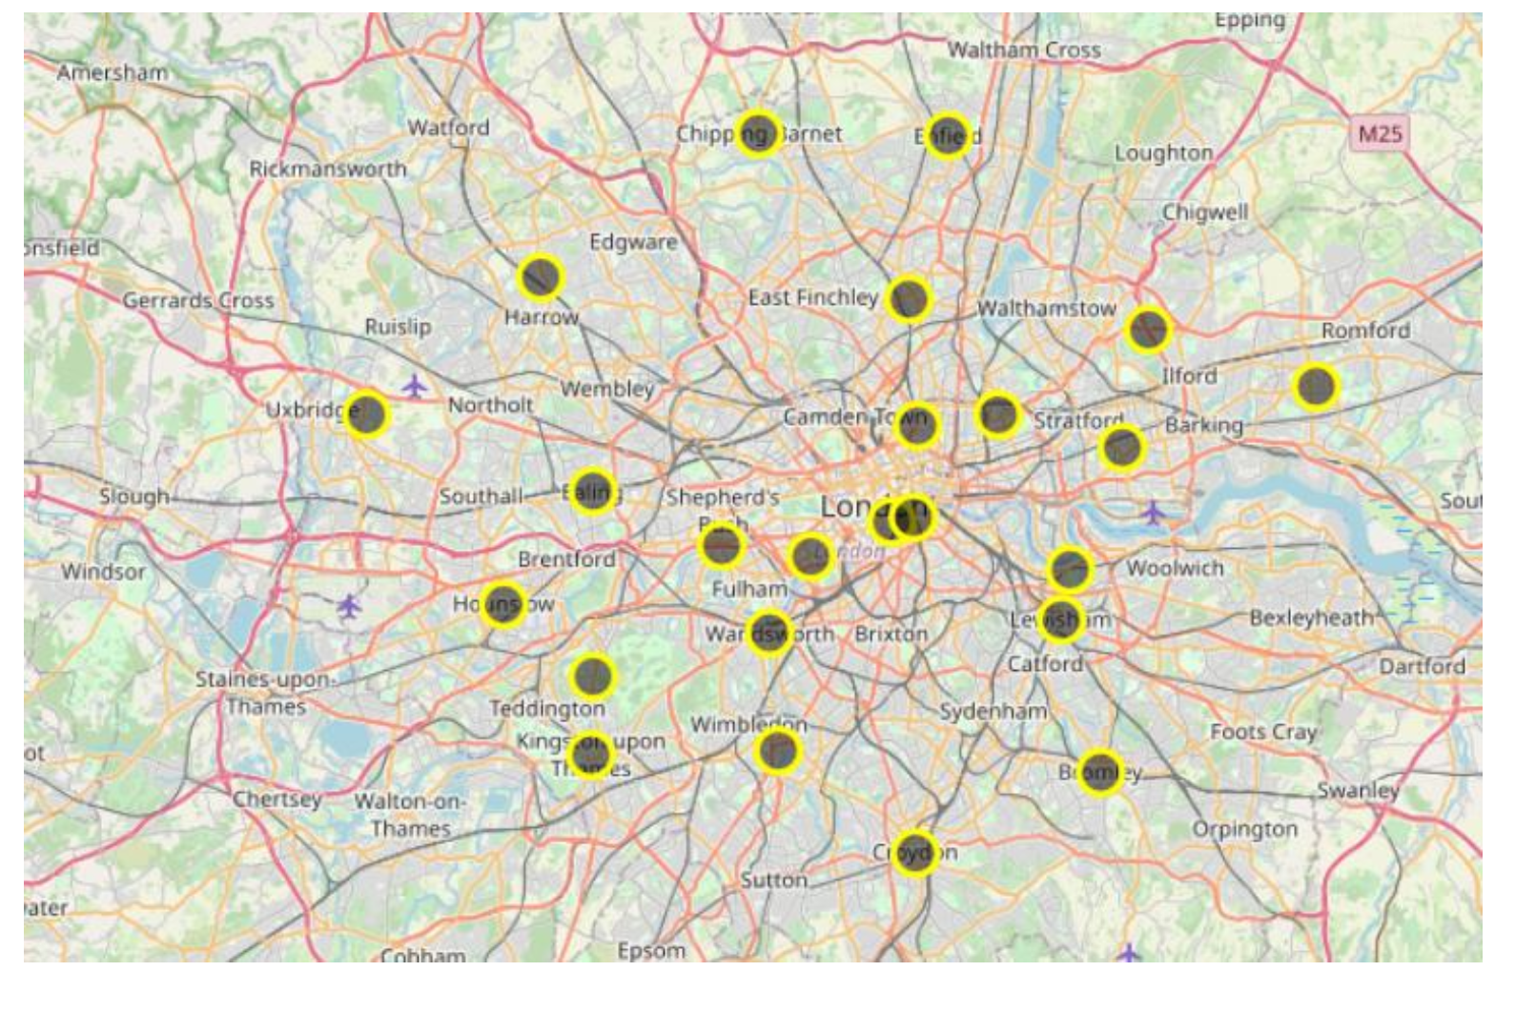

By using K-means clustering of the restaurants of the Croydon area will be clustered and segmented and analyzed based on the ratings of customers given to the restaurant.

**Results**:

The restaurants spots are identified in the folium map by the areas where the population is in huge numbers and thereby revenues can be increased with the setup of new restaurants and if restaurants are already present in that area then new items will be introduced in the menu.

**Conclusion:**

More number of Indian recipes will be introduced in the Indian restaurants thereby increasing the sales of restaurants in all the boroughs of London